Assemblage
The Art and Science of Brand Transformation
Media kit

Contents
Contact information 1
Book info 1
Copy 2
Photos 3
Bio 3
Photos of Emmanuel 4
Interview resources 5
Interview topics 5
Sample interview questions 6
Press release 7
Praise for Assemblage 7

Contact information
- Media enquiries, event/booking information and review copies: Marine@emmanuelprobst.com
- Everything else: Emmanuel@emmanuelprobst.com
- LinkedIn: https://www.linkedin.com/in/emmanuelprobst/
- Website: emmanuelprobst.com

Book info
- TITLE: Assemblage – The Art and Science of Brand Transformation
- AUTHOR: Dr. Emmanuel Probst
- PUBLISHER: Ideapress Publishing
- DATE OF PUBLICATION: 24 January 2023
- RETAIL PRICE: $28.95
- ISBN-13: 978-1646871254
- PAGES: 240 - Hardcover
- Link to the Amazon page

Copy
- Longform copy for blog posts, newsletters, email campaigns, etc.
Brands can no longer force-feed us a plethora of products we don’t need. To succeed, brands must transform us and the world we live in. Assemblage guides you through the art and science of creating transformative brands by combining personal, social and cultural attributes.
In particular, Assemblage will show you:
  - How to shape consumers’ perceptions
  - Why we relate with anti-heroes, villains,
and saviors
  - How brands can reassure consumers about the future, by leveraging the past and the present
  - How to utilize data and insights to deliver
a personalized, human-centric
consumer experience
  - How brands can make a positive impact on people, society and the economy
  - What Picasso knew, and all marketers need to learn

Assemblage is supported by in-depth research in consumer psychology, extensive consumer insights, interviews with industry-leading marketers, and case studies of transformative brands, big and small.

- Shortform copy
Brands can no longer force-feed us plethora of products we don’t need. To succeed, brands must transform us and the world we live in. Assemblage guides you through the art and science of creating transformative brands by combining personal, social and cultural attributes.

Photos

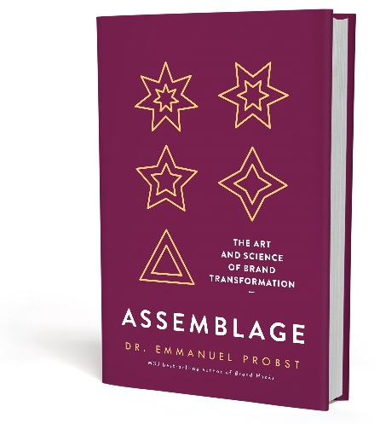

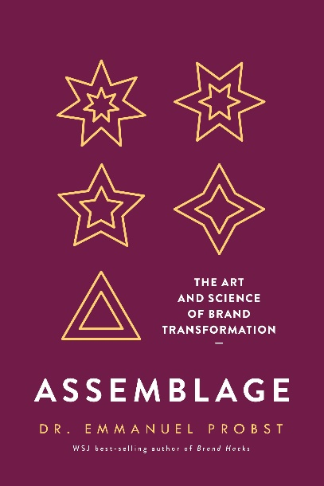

Bio
Emmanuel Probst is Global Lead, Brand Growth and Thought-Leadership at Ipsos, adjunct professor at the University of California at Los Angeles and a Wall Street Journal and USA Today best-selling author of Brand Hacks and Assemblage – The Art and Science of Brand Transformation.
Emmanuel’s background combines 20 years of market research and marketing experience with strong academic achievements.
At Ipsos, Emmanuel supports numerous Fortune 100 companies by providing them with a full understanding of their customer’s journey. His clients span across a wide range of industries, including consumer packaged goods, retail, financial services, advertising agencies and media outlets.
Emmanuel also teaches Consumer Market Research at UCLA and writes about consumer psychology for numerous publications.
He holds an MBA in Marketing from the University of Hull, United Kingdom and a Doctorate in Consumer Psychology from the University of Nottingham Trent, United Kingdom.

Photos of Emmanuel

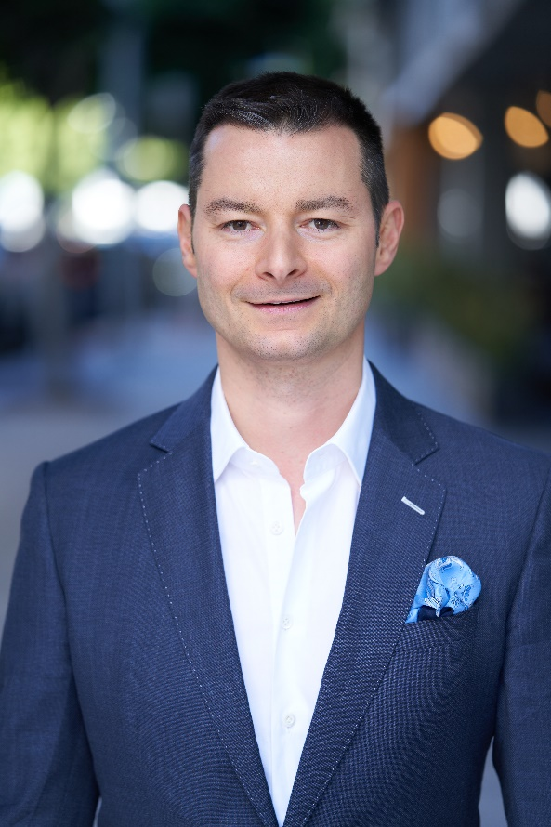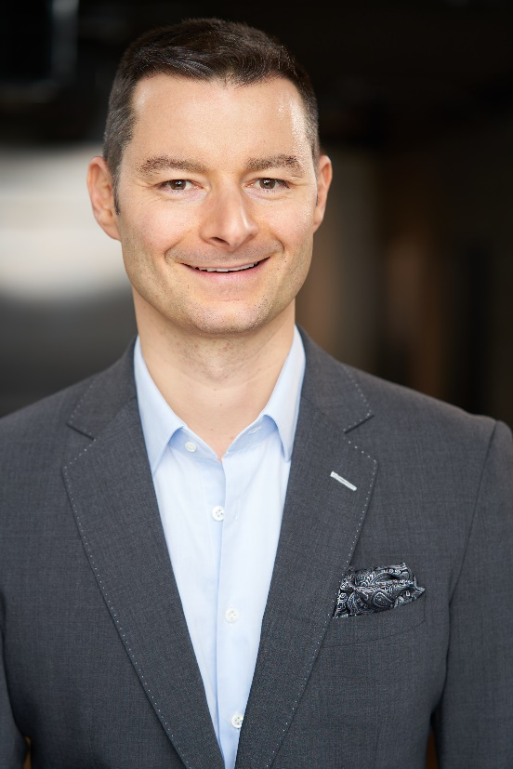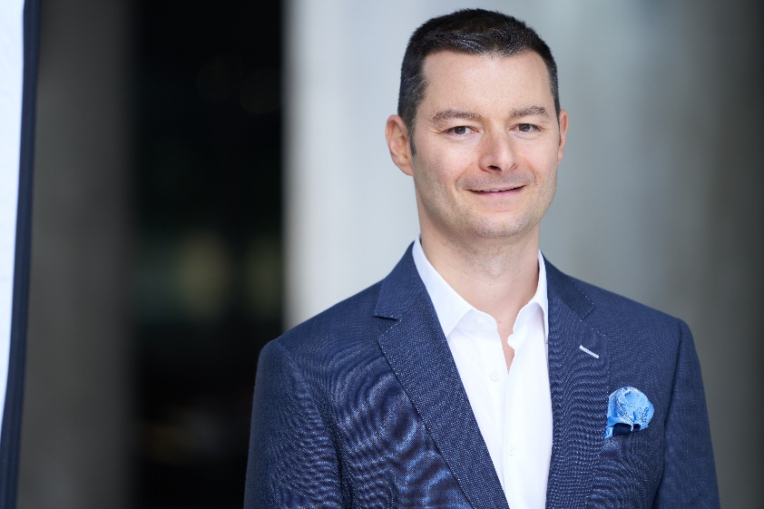

Interview resources

Bio talking points: Introduction of Emmanuel Probst
Dr. Emmanuel Probst is the author of Assemblage – The Art and Science of Brand Transformation. Assemblage is widely acclaimed by Jonah Berger, Martin Lindstrom, David Aaker and Nir Eyal, among other thought-leaders.

Emmanuel is both an academic and marketing professional
- Throughout his career, Emmanuel has balanced academic and market research
- He has been studying why people buy for 17 years. Emmanuel holds a Doctorate in Consumer Psychology, teaches market research at UCLA.
- In the meantime, he works for Ipsos advising Fortune 100 brands on how to measure an optimize the impact of their marketing.

Off the stage
- Emmanuel and his wife Marietta have two sons, Theo and Etienne
- Their dog Toffee is supposed the help with his writing
- They live in Los Angeles, California
He is here [this morning/this afternoon/this evening] to speak to us on the topic of
[speech title]. Please join me in welcoming Emmanuel Probst.

Interview topics

Consumers are sick of marketing and advertising
Each year, brands spend over $600 billion (and counting) to convince us to buy their products. The reality is that Brands can no longer force-feed us plethora of products we don’t need. To succeed, brands must transform us and the world we live in.

The New Era of Brand Relevance
When choosing a product, we do not think of brands and categories in isolation; we make our choice in light of the occasion and the particular needs associated with it.
Brands become more relevant by developing interconnected sets of products and services centered around the attitudes and aspirations of their target audience.

The Assemblers
The artists we admire the most are talented, but not always in the way we may think. Their real talent is often assembling to deliver their artistic vision, rather than necessarily creating the work of art. They can teach us how to cope with our impostor syndrome, and create and market brands at scale

Sample interview questions
- What is an Assemblage?
- Why is this important to marketers, all the sudden?
- What are different types of attributes you can assemble?
- In the book, you talk about anti-heroes, saviors and villains. What does that have to do with brands?
- One of the chapters is titled “Perception is The Truth.” You mean the truth doesn’t matter?
- You argue that most creations of the arts, music, marketing, and even technologies are not original?

- You also believe that consumers feel lonelier than ever. Why? What can brands do about it?

- Your first book, Brand Hacks, became a Wall Street Journal best-seller. How has your writing evolve since you published Brand Hacks in 2019?

- In the book, you look at the big brands we all know (Dove, AirBnb…), along with much smaller brands, like Farrow&Ball. Why?

- You say that we all seek reassurance about our past, present and future. What do you mean by that?

- You say that Pharrell Williams can’t read music and Jeff Koons doesn’t even make his art pieces. Is it because you are jealous of their fame and money?

- “Brand purpose” has become a buzzword in the marketing community. What is your take on that?

- “Storytelling” is another buzzword that has been the topic of dozens of articles and books. What is your contribution to Storytelling?

- How has the advertising industry changed over the last few years?
- To conclude, tell us one last thing that will inspire us to become assemblers

Praise for Assemblage

The only way to find brand success and growth is to reframe perceptions and decisions. Probst provides routes to doing just that. A real contribution.
David Aaker, Vice Chairman at Prophet, Brand Strategist and Author of "The Future of Purpose-Driven Branding"

Want to create a transformative brand? Assemblage shows you how, illustrating how brands can do good for both consumers and society
Jonah Berger
Wharton Professor and Bestselling author of Contagious and The Catalyst

Assemblage blends academic research with practical insights that marketers can immediately put to good use. It's a clear, concise, and actionable book.
Nir Eyal
Author of Hooked and Indistractable

Assemblage offers a holistic understanding of brands and perceptions – it is a must-read.
Martin Lindstrom
New York Times Best-selling author of Buyology and the Ministry of Common Sense

As Jeremy Bullmore famously said, 'People build brands the way birds build nests - from the scraps and straws they find lying around.' Using the model of assemblage, the art of blending fine cognacs, Emmanuel Probst provides us with a much more helpful and versatile mental model for the way brands are built in practice It is also an approach which rings true with what we are increasingly learning about human perception and behaviour.
Rory Sutherland
Vice Chairman, Ogilvy UK

Assemblage is the book I have been waiting for. Its standpoint on the marketing industry is disruptive. Its learnings are pragmatic.
Scott McDonald, President & CEO – Advertising Research foundation

Assemblage shows the transformation power of brands for both consumers and society. It's simply a must read.
Neil Hoyne
Chief Measurement Strategist, Google

Marketers and brands now have the opportunity to make a positive contribution to consumers and society. Assemblage is your ultimate guide for this new brand era.
Jeff Rosenblum
Author of Friction and Exponential

